Roadmap Procedure
February 5, 2026
10:19 AM

Physical Certificate Deposit

Pershing 50 cents price floor for deposit
Any restricted securities by RJF can not be deposit
Check Sedar+ and CTO

- DRS
  - Restricted DRS - Shares have legend on DRS
    - Only With CCO approval - foreign free receive
    - Can not be deposited - ask client to convert to Physical Certificate with transfer agent
  - Clean DRS - talk to operation to do the DRS account transfer.
- Physical Certificate
  - Non legend shares clean shares and restricted/legended shares

We need to do the due diligence review
Files needs
LPSQ is always required
If any questions, go back to FA and Update., make sure the signature is correct

- Once all done,send all files and LPSQ to BM for review and signature
- Save BM email and all reviewed files in the LPSQ Approval folder
- Send FA email ask for tracking number
- Log it
- Once get the tracking number, and send a service request to pershing to track the deposit

It will show up in the daily trade review. Make appropriate comment

Legend Removal

Sometime advisor send document to pershing to start the legend removal before notifing us, so we need to check the Items for attention regualarly.

There are requirrement for legend removal, verify the holding period or get confirmation from the issuser to process. we can not advise whether legend removal will be successful or not. Its up to the issuer and transfer agent to determine.

Client send document,

We prep the broker's letter in the compliance folder, send it to BM for wet signature, and BM needs to sent it to Pershing and also give us a scan copy for record.

Once pershing received, -perhisng can do a RUSH order for a fee(400)
Pershing will send it to their canandian agent and then to the transfer agent to process.

Once clean share received, it will show up in the daily trade review,
Once you see this record, check the transaction in the account, if confimed,

Charge client fees and log it
Place a PACE block on the account
Place a note on the account

Legend Removal 350 Fee
February 5, 2026
10:06 AM

Legend Removal Fee $350

1.Charge Review Fee
- NETX -> open client’s account -> On the top choose: servicing -> asset movement -> journals + between accounts, continue -> receiving account = sundry account: AJR890698 -> continue -> request reason: fee -> admin fee -> disclosed to the client? Yes -> all comments: DD – Review Fee – (stock name) -> change amount to $350.00 CASH (move qty/amt)-> review before sending -> paste the comment again -> send
- Update both spreadsheets (daily trade report and master spreadsheet)

- After charging review fee, put a PACE block on the account to prevent the security from being transferred out.

2.Flag an Account (PACE block)
- Click Service & Operations > OpsCenter.
- Click PACE - Pershing Automated Cash Exchange.
- If you want to search, In the Account Information section, click FLAG-Account Flags.
- In the Account field, type an account
- Click Add.
- In the From Account box, type the account number.
- In the Flag box, select the block
- In the Reason field, type reason code: COR
- Press Enter. The Block or Hold will be processed.

- 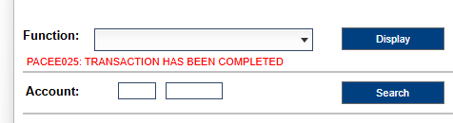

- Add note on Netx
- 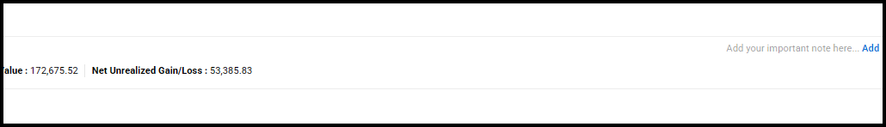

e.g.
VW on 07/16/24 - Legend removal of *** shares of ***., under Rule 904. Stock cannot be traded on any US market and cannot knowingly be sold to any US resident. Stock cannot be transferred out of account without BM/Compliance approval.

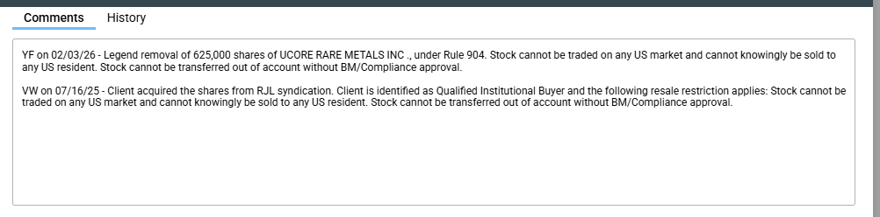

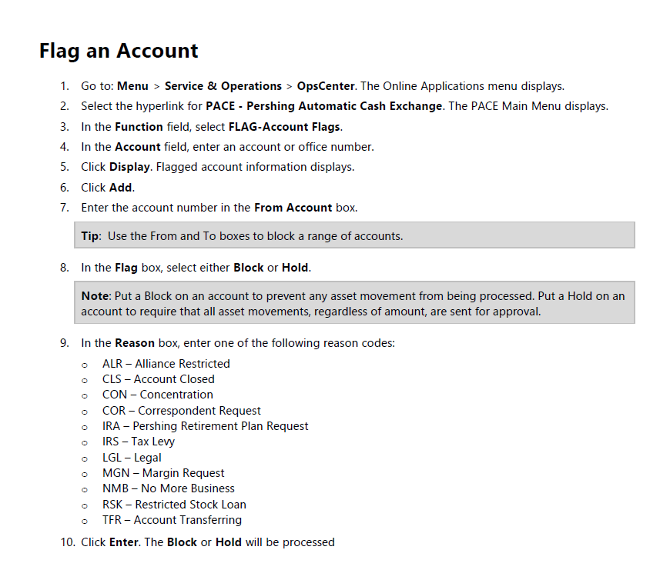

LPSQ
Thursday, February 05, 2026
10:11 AM

Low price securities deposit R:\Compliance Oversight\LPSQ approvals

If DTC eligible is no, then it need to be phy cert

RSTK is a label used in client accounts to indicate Restricted Stock.
LPSQ is a compliance form used when a client wants to deposit or trade low-priced securities (often under $5 per share).

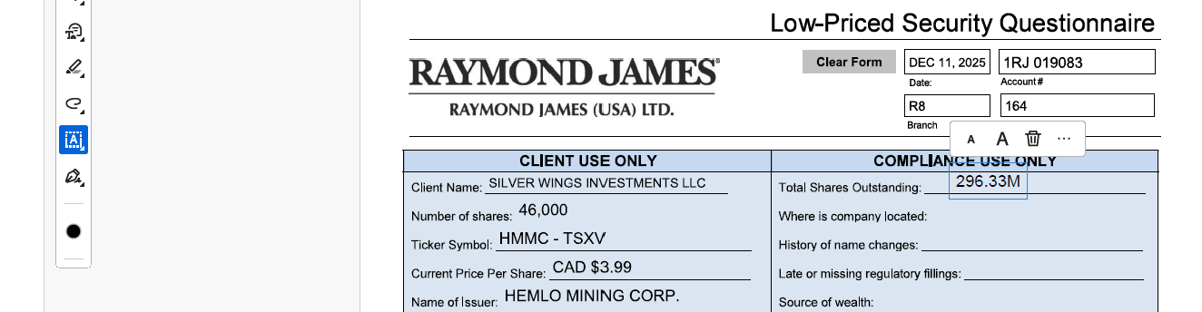
🗂️ Document & Form Retrieval
- Obtain Irrevocable Stock Power (if they only require deposit then they don’t need to provide)and physical certificate together
- Stock power form location: RJNet > Home > Operational Forms and Procedures
📊 Company & Share Verification
- Check total shares outstanding: Yahoo Finance > Statistics , find total shares outstanding
- , go to company name+tsxv for more data
- OR FACTSET-Financials-reported shares analysis
- For " where is company located", Canadian companies: check yahoo Profile
- History of name change: search company name+ name change
- verify regulatory filings via SEDAR+ (check for missing/late documents), enter company name in " select profiles to search on" others things unchanged and click search
- Check if the company in SEDAR+ is Cease Trade Order
There are 4 files we need to check: Interim financial statement, interim MD&A, Certification of interim filings CFO and CEO make sure these 4 files exist
- For U.S. companies: search EDGAR (SEC filings)
- Determine insider/outsider status via SEDI
🔎 Account Due Diligence
- Occupation: New Account Form-Employment status and industry affiliations- occupation
- Check source of wealth: NetX360 > Document Center > New Account Form - step 3. USA Patriot Act information)
- Confirm whether securities are restricted to RJF
- What percentage of outstanding shares do you own? Go to netx 360 positions and find all same name shares, then add all and the shares on form together, then divided by total shares outstanding: question 7 total shares you own divided by total shars outstanding on the form
📨 Branch Workflow
- Use template Send an email to FA after Branch Manager approval
- Log details accordingly
📁 Compliance Folder Management
Save in the folder:R:\Compliance Oversight\LPSQ approvals
📈 Tracking Spreadsheet
- Update/maintain: Low-Priced Large Share Deposit Due Diligence Spreadsheet (Excel format)

Read documents provided by FA and find out:
How did client acquire the shares?

Read reqstion 10: check physical certificate

Check if there's past deposit
Check legend free, where client get the warrant

Documents and Review Process
- Required Documentation
  - Scanned copies (front and back) of physical stock certificates, ensuring legibility.
  - A completed Low Price Security Questionnaire (LPSQ).
  - Electronic signature summary (if applicable).
  - Supporting documents (e.g., subscription agreements) showing how the shares were acquired.
- Compliance and Approval Steps
  - RJLU Compliance reviews all materials and may contact the FA/client for any needed clarifications. LPSQs and supporting documents are saved in our shared drive.
  - Once approved, the Branch Manager reviews all supporting documents and signs the LPSQ.
  - Certificates are then sent to Pershing Custody for final review. Accepted securities are deposited into the client’s account.
  - If restricted, the position appears as RSTK in client’s holding.
  - When legend-free shares are issued, RJLU Compliance restricts the account with a note specifying that these shares: Cannot be traded on any U.S. market. Cannot be knowingly sold to any U.S. resident. Cannot be transferred without Branch Manager/Compliance approval.

Sending to Branch Manager email example:
Good morning Milene,

Please find attached the LPSQ and related supporting document for your review.

Client Frederick Morton, P74058028, requested to deposit 28,111 shares of Yangarra Resources Ltd, which is currently trading at $0.76 USD.

Client is currently an insider and a board director of the issuer. From the Sedi report attached, we can confirm that the client acquired the shares from exercise of rights. We also got confirmation from the issuer that the shares issued are unrestricted and fully vested. The deposit has been reviewed by the RJLU CCO, Ash Chester, and compliance has no further concerns regarding this deposit.

Kindly review and provide us with a signed copy of the LPSQ, if approved on your end.

Kind Regards,
Vincent

Sending to FA email example:
Good afternoon Haani,

The LPSQ has been reviewed and approved by Branch Manager. We are good to proceed with the deposit.

Please ask your client to complete the following instructions to deposit the 20,000 restricted shares of ECare Solutions, Inc,:

The client is to send to Pershing via FEDEX/UPS all the following original documents:

- Original Stock Certificate (please have the client’s RJLU account number in the top right-hand side of the certificate)
- Stock Powers – signed by the registered holder with a wet signature.

Pershing’s address to receive those documents is:

Attn: Securities Receive Department
PERSHING LLC
1 PERSHING PLAZA
7TH FLOOR CUSTODY GROUP
JERSEY CITY NJ 07399

Kindly ensure to provide me with the courier’s tracking number ASAP.

Kind Regards,
Vincent

Daily and Monthly Procedure
Thursday, February 05, 2026
10:14 AM

RSTK-HRS-LP tab
  - In the raw data, untick AJR; Security Name -> filter search RSTK under security name & Received into your account & Security received & restricted item… under Type of Entry Code Description
  - If something shows up, record details in the RSTK tab
  - If there’s no new deposit, write ‘’nothing for (report’s date)’’ in the tab
When ‘’restricted item cleared’’ shows up, it means that the legend on the shares was removed. And the following steps will be taken:
  - Update the details on the master spreadsheet (R drive -> Supervision -> Low price large share dep log): check to see if we need to charge DD review fee. Don’t charge $250 ($350) review fee for P74 & P75
  - If we need to charge the $250 (upgraded price to $350) DD fee:
Charge Review Fee
  - NETX -> open client’s account -> On the top choose: servicing -> asset movement -> journals + between accounts, continue -> receiving account = sundry account: AJR890698 -> continue -> request reason: fee -> admin fee -> disclosed to the client? Yes -> all comments: DD – Review Fee – (stock name) -> change amount to $350.00 CASH (move qty/amt)-> review before sending -> paste the comment again -> send
  - Update both spreadsheets (daily trade report and master spreadsheet)

  - After charging review fee, put a PACE block on the account to prevent the security from being transferred out.
Flag an Account (PACE)
  - Click Service & Operations > OpsCenter.
  - Click PACE - Pershing Automated Cash Exchange.
  - In the Account Information section, click FLAG-Account Flags.
  - In the Account field, type an account or office number and click Display. The flagged accounts display.
  - Click Add.
  - In the From Account box, type the account number.
  - In the Flag box, select the hold button.
  - In the Reason field, type reason code: TFR - Account Transferring
  - Press Enter. The Block or Hold will be processed.
Notes:
  - If LGL code is entered, only Pershing Legal can remove the block/hold
Flip Symbol to CAD
  - If we removed the legend under Rule 904 which doesn’t allow the shares to be sold in the US, we need to flip the symbol to the Canadian symbol. A SCR example is shown as:
Work Status - Customer Initiated Request

Request ID: SCQ8E000017C  Status : Pending Review | Target Completion Time : PER: NA  IBD: NA

Category  Asset Movement | Request  Journals | Request Type  Non-USD Currency/Position

* Required Information

Attached files will not be imaged and will not appear in Online Documents.

Account #:* | 1RJ017061 | Title: | FERRY CAPITAL LLC  941 DIAMOND ST  SAN FRANCISCO CA 94114-3626 | Category: | LLCP
IBD NAME: | RAYMOND JAMES USA LTD

Subject/Attention: | Move to CAD symbol

Request Details
Request Type :* Par to Gloss | Currency :* CAD-Canadian Dollar
Debit Account : | Credit Account :
Security ID: | CUSIP 02075W105 02075W105 ALPHA LITHIUM CORP COM ISIN#CA02075W1059

Amount: | Quantity: 278,100
Additional Information: | Please have the position moved from PAR to GLOSS  (USD currency to CAD currency)  The Canadian symbol is ALLI  CUSIP 02075W105

LPSQ Deposit Procedure
Thursday, February 05, 2026
10:16 AM

Low Price Security Physical Certificate Deposit Procedure

What the process,

Then say it will go through a review.
Then tell them next steps
Baby steps. Simply steps
No garatueens, may be additional doc require

Also a internal desk procedure

Security/Issuer Eligibility of Deposit/:
Firm’s policy of low price security prohibit deposit of securities/issuers that are either:

  - Designated prohibited securities
    - To check if a security is currently prohibited, please download the latest Prohibited Security Search tool
  - the current price of common stock of the security issuer less than 50 cents per share (USD)
  - Assigned to Grey Market or Expert Market Tier
  - Designated Caveat Emptor

Compliance Due Diligence Review:

To proceed with the deposit of restricted low-price securities,

  - it is necessary for the client to obtain physical stock certificates from the transfer agent,
  - provide documentation supporting the acquisition of these shares.
  - Additionally, please ensure the Low-Price Security Questionnaire is fully completed, signed and dated by the client.

For compliance review by RJLU, kindly submit the following documents to Compliance@RJLU.com

  - Scanned copies of both the front and back of the physical stock certificates.
  - The completed and signed Low Price Security Questionnaire.
  - Supporting documents pertaining to the acquisition of shares.
  - Must be valid legal documents detailing the acquisition.
  - Documents must be signed and dated on the original acquisition date.
Fees:
Only for deposit into commission based account, a fee charge of $350 USD will be applied upon legend removal.

PACE Block Notes
February 5, 2026
10:09 AM

PACE Block Notes
- VW on 07/16/24 - Legend removal of *** shares of ***., under Rule 904. Stock cannot be traded on any US market and cannot knowingly be sold to any US resident. Stock cannot be transferred out of account without BM/Compliance approval.
- VW - 11/20/2024 - Legend removal of 87,270 shares of Cyberfuels Holding Company Inc (CBRF)., under Rule 144 - No PACE Block Required.
- VW on 09/25/24 - PACE Block placed due to client computer was hacked. RJL Privacy has been notified.

Pershing Notes
February 5, 2026
10:10 AM

Request Physical Certificates

- Non-Low Price Security (Not deposited via physical cert)

The Cusip you are requesting is DRS eligible and the fee is $10. If the address on NetX360 is her home address, then that is where the statement would go. If she wants a different address, then we would need a letter of authorization uploaded to the account with the Pershing account number, stock type, number of shares and new address with the client’s signature. Also, you would just need to send a service center to Custody – Transfer and Ship to have this processed. The complete process takes 7 – 10 business days.

- Transfer the Certificates out from Safekeeping to client address on file

Asset movement, Outgoing transfer - Partial
It would be my pleasure to help with this inquiry. For the receiving broker and receiving broker type those would be left blank. Only box that would need to be filled is "Delivering Account#" which would be "1RJ" and then select "Select safekeeping positions from holdings".

- For clarification purposes, when you refer to “DRS eligible” in your latest reply, what exactly you are referring to?

Some transfer agents do not process DRS (electronic shares), they only deal with certificates. We are checking with the transfer agent to make sure that cusip can be sent electronically and does not need to have a physical certificate issued.

Extension Request
Move to Safekeeping

n reference to item #1, we have never received the check for $200 to process the certificate.
In reference to item #2, we are still waiting for the $125 check to clear for the DRS.
All of the transfers have been processed. Please allow 7-10 business days for the DRS items to be
completed and 10-15 business days for the certificate to be completed.

LPSQ BM Approval
May 24, 2024
1:57 PM

So because of the other PSQ process has a price floor at the moment so that the amount of deposit has reduced significantly so not much a point to still have a new track log for this process. It's determined that no more so we are not using a new log which is keeping using the old log and also in terms of the L PS: Q folders there's something we need to discuss with Barb to see if there's anything we can consolidate in our shared drive to make sure that everything is in the consolidated place.

Subject

Good morning Sonia,

Please find attached the LPSQ and related supporting document for your review.

Client Robert Weiner, 1RJ015818, requests to deposit 20,000 restricted shares of ECare Solution Inc. Client has made multiple deposit of the same security in the past.

Client’s current holding of this security is as illustrated in the table below.

Account Number | Client Name | CUSIP | Restricted ISIN | Security Description | Trade Quantity | %OS | IP Name
Existing Position
1RJ015818 | ROBERT WEINER | 278744909 | N/A | RSTK ECARE SOLUTIONS INC COM | 87,270 | 0.100% | GRANT KEDWELL
1RJ012294 | WEINER INVESTMENTS AND HOLDINGS LP | 278744107 | US2787441078 | ECARE SOLUTIONS INC COM | 2,166,783 | 2.474% | GRANT KEDWELL
1RJ015818 | ROBERT WEINER | 278744107 | US2787441078 | ECARE SOLUTIONS INC COM | 501,365 | 0.573% | GRANT KEDWELL
 |  |  |  | Combined Position | 2,755,418 | 3.147% | Of Outstanding Shares

The securities are neither CSRG/RJF restricted nor related to any prohibited sectors (such as marijuana or cryptocurrency).

Based on the provided documentation, RJLU Compliance has no concerns regarding this deposit.

Kindly review and provide us with a signed copy of the LPSQ, if approved on your end as well.

Thank you,
Vincent

Good afternoon Sonia,

Please find attached the LPSQ and related supporting document for your review.

Client Steven Van Ert, 1RJ013706, requests to deposit 85,000 restricted shares (Certificate# 4604) of Timberline Resources Corp.

Client has deposited 85,000 shares (Certificate# 4407) in June 2024.

The securities are neither CSRG/RJF restricted nor related to any prohibited sectors (such as marijuana or cryptocurrency).

Based on the provided documentation, RJLU Compliance has no concerns regarding this deposit.

Kindly review and provide us with a signed copy of the LPSQ, if approved on your end.

Thank you,
Vincent

Certificate Deposit - Secondary Review
May 27, 2024
2:48 PM
Good morning Mario,

As requested by Steven Richardson, the warrant deposit for X MACHINA CAPITAL STRATEGIES FUND I LP (XMC Fund 1RJ020669) is expedited considering the time sensitive for the warrant exercise timeline.

About the warrant being deposited:

- The expiration date of the warrant is August 24, 2024
- The warrant has a restrictive legend on it.
- The warrant is for 637,500 common shares, this warrant is part of the subscription package of 1,275,000 common shares acquired from the issuer on August 11, 2022. Subscription agreement is provided as supporting document.

About the Zefiro Methane Corp (Zefiro 98926D106):

- The issuer was formerly known as Caden Capital Corp. and changed its name to Zefiro Methane Corp (Zefiro 98926D106). in September 2022
- RJL is part of the syndication in its IPO on April 23, 2024
- This security is currently NOT restricted/prohibited.
- RJLU’s current combined positions are as follow:
Security Information
Security Name | Zefiro Methane Corp. | Primary Exchange | Cboe CA
Cusip | 98926D106 | Other Exchange
Total Outstanding Shares | 63,359,500 | Corp Address | Vancouver, Canada
Holding Information
Account Number | Client Name | CUSIP | Restricted ISIN | Security Description | Trade Quantity | %OS | IP Name
Existing Position | as of May 17, 2024
1RJ020669 | XMC Fund | 98926D106 | CA98926D1069 | ZEFIRO METHANE CORP REGISTERED SHS ISIN#CA98926D1069 | 25,000.00 |  | WES KORHONEN
1RJ020305 | TIMOTHY EUGENE SULLIVAN | PER989057 | N/A | RSTK ZEFIRO METHANE CORP REGISTERED SHS | 90,000.00 |  | WES KORHONEN
1RJ020669 | XMC Fund | PER989057 | N/A | RSTK ZEFIRO METHANE CORP REGISTERED SHS | 420,200.00 |  | WES KORHONEN
 |  |  |  | Combined Position | 535,200 | 0.845%
Pending Deposit
1RJ020669 |  | PER989057 | N/A | Warrant - RSTK ZEFIRO METHANE CORP | 637,500 | 1.006% | WES KORHONEN
 |  |  |  | Combined Position | 1,172,700 | 1.851%

About the Client - XMC Fund 1RJ020669

- Client account was open on March 25, 2024, to purchase IPO shares (as an insider) through Raymond James syndication.
- Client is a major shareholder of Zefiro, according to the LPSQ and Sedi Report, client holds 19,395,200 shares, which is 29.54% of outstanding share.
- Client’s RJLU account appears to only holds Zefiro shares, details as follow:
Security | Quantity | Market Value | % of Portfolio
RSTK ZEFIRO METHANE CORP | 420,200.00 | 490,887.72 | 50.65
LIQUID INSURED DEPOSITS | 449,130.60 | 449,130.60 | 46.34
ZEFIRO METHANE CORP | 25,000.00 | 40,000.00 | 3.01

Here is some highlight of the case:

- Client is a major shareholder (29.54%) of the issuer.
- Client’s holds only this security in its RJLU account, which accounts for around 54% of the Portfolio.
- The warrant has a restrictive legend on it.
Please kindly review and share your comment on this deposit, thank you!

Kind Regards,
Vincent

Certificate Deposit - 5% threshold
May 29, 2024
11:40 AM

Good morning Haani,

Upon review of all the paperwork related with the request to deposit physical certificates of DHR into Richard Gilliam’s RJLU account (1RJ015594), we have identified the following concerns:

- It was noted that the client is a majority shareholder and director of the company. Currently, the client holds 600,000 shares in their RJLU account, which equates to approximately 6.3% of the outstanding shares in our books. The addition of 849,698 (246,364 + 603,334 shares represented in two certificates) restricted stock, along with the 600,000 unrestricted portion from a previous deposit, would elevate the client's RJLU account exposure to DHR to 1,449,698 shares or 15.34% of outstanding shares. According to our Firm’s risk tolerance standards and approach, the maximum permitted exposure to a security is capped at 5% of outstanding shares. As you can see, the current request to deposit those additional shares of DHR would further increases client’s exposure, therefore, going against the Firm’s 5% permissible threshold.

- At this point, the client has not provided sufficient formal evidence of documents linked to the acquisition of the 849,698 restricted shares (246,364 + 603,334 shares represented in two certificates) of the issuer. Unfortunately, the DHR Position log provided is not a valid document that meets that requirement.

Considering those concerns, we will not be able to proceed with approving the physical certificates deposit request by your client.

Best regards,
Vincent

<<RE_ Stock Deposit - Ariel Fogel - 1RJ017137.msg>>

Certificate Deposit - Standard Language
May 30, 2024
10:26 AM

Signature

For any corrections or amendments on the LPSQ, kindly ask that your client signs or initials beside each change. If using an electronic signature platform, such as DocuSign, please include the signature summary to confirm the client’s identity and the authenticity of the signature.

Certificate Deposit - After BM Approval
June 3, 2024
4:55 PM

Good afternoon Haani,

The LPSQ has been reviewed and approved by Branch Manager. We are good to proceed with the deposit.

Please ask your client to complete the following instructions to deposit the 20,000 restricted shares of ECare Solutions, Inc,:

The client is to send to Pershing via FEDEX/UPS all the following original documents:

- Original Stock Certificate (please have the client’s RJLU account number in the top right-hand side of the certificate)
- Stock Powers – signed by the registered holder with a wet signature.

Pershing’s address to receive those documents is:

Attn: Securities Receive Department
PERSHING LLC
1 PERSHING PLAZA
7TH FLOOR CUSTODY GROUP
JERSEY CITY NJ 07399

Kindly ensure to provide me with the courier’s tracking number ASAP.

Kind Regards,
Vincent

Remove Legend
June 4, 2024
4:13 PM

Sundry Account
AJR890698

Charge Review Fee
  - NETX -> open client’s account -> On the top choose: services & operations -> asset movements -> continue -> receive a/c #: AJR890698 -> continue -> request reason: fee -> admin fee -> disclosed to the client? Yes -> all comments: DD – Review Fee – (stock name) ->amount is $250.00 CASH -> review before sending -> paste the comment again -> send
  - Update both spreadsheets (daily trade report and master spreadsheet)

  - After charging review fee, put a PACE block on the account to prevent the security from being transferred out.

Pershing 50 Cents
July 4, 2024
2:24 PM

Hello Milene,

According to the attached Compliance Bulletin, Pershing will no longer accept physical certificates and DRS (electronic) deposits of securities that are priced less than $0.50 USD per share. Considering the security price of 1 pence per share, we may not be able to deposit those shares into client’s RJLU account.

Please kindly let me know if you have any further questions.

Kind Regards,
Vincent

How to
July 10, 2024
2:23 PM

Legend Free shares,

- Legend was previously removed

The client currently holds 16,667 shares of BQE, which were deposited using Physical Certificates. The legend associated with these shares was removed on July 31, 2021.

Please note that the client cannot transfer out these shares. However, if the client wishes to withdraw the shares, they will need to provide a Letter of Authorization (LOA) requesting the return of the shares in the physical certificate format. In this case, we would need to reapply the legend to the shares.

Process

Service Center Request

Custody - Pending Paper - General Inquiry

- Needs to make sure the security is DRS eligible
- Fees is 125 USD, needs to be available before processing.

As per LOA attached, please proceed according to
the following:
1. re-issue the stock certificate with the
restrictive legend of the 1933 Act to the
applicable balance of 4,750,000 shares of QUISF
(original certificate: 00100084ZQ), and send it
to the client's address on file.
2. Issue a stock certificate for the remaining
4,824,910 unrestricted shares (deposited via DRS)
and send it to the client's address on file.
Kindly provide the overnight tracking number once
process for our follow up.
Please note that for the stock certificate number
00100133ZQ (560,489 restricted shares), there is
separate SCR: SCU1N0000213 already pending
review.
Thank you.

CTO
October 29, 2024
1:07 PM

Trading is currently halted for this security and has not traded on the OTC since July. I would reach out to your Custody department for information on writing off/deleting the security.

Legend Free
November 20, 2024
11:50 AM

LPSQ - 1RJ021980 - Cyberfuels Holding Company Inc - 40,000 shares

Good morning Sonia,

Please find attached the LPSQ and related supporting document for your review.

Client Alice Axenfield-Storm has requested to deposit 40,000 legend-free shares of Cyberfuels Holding Company Inc. (CBRF). The issuer, previously known as EncounterCare Solutions, Inc., changed its name to Cyberfuels Holding Company Inc. in August 2024.

The certificates pending deposit are legend-free, and the client acquired the shares via SPA on May 18, 2023. The legal opinion letter and records from the transfer agent are provided to support the legend removal.

This security is currently trading at $0.71USD. We have advised the client on the Pershing’s new low priced security policy that Pershing may reject the deposit if the share price fall under $0.5USD.

The securities are neither CSRG/RJF restricted nor related to any prohibited sectors (such as marijuana or cryptocurrency). Based on the provided documentation, RJLU Compliance has no concerns regarding this deposit.

Kindly review and provide us with a signed copy of the LPSQ, if approved on your end as well.

Thank you,
Vincent

<<Disposition of Existing Physical Certificate Holdings Priced at Less than $0.50 USD.PDF>><<Low-Priced Securities Update.PDF>>
Low Price Security Certificate Deposit Procedure and Updates
April 2, 2025
9:32 AM

Hello Barb,

Below is our procedure for Low Price Security Certificate deposits, along with recent Pershing updates and current statistics.

Documents and Review Process
  - Required Documentation
    - Scanned copies (front and back) of physical stock certificates, ensuring legibility.
    - A completed Low Price Security Questionnaire (LPSQ).
    - Electronic signature summary (if applicable).
    - Supporting documents (e.g., subscription agreements) showing how the shares were acquired.
  - Compliance and Approval Steps
    - RJLU Compliance reviews all materials and may contact the FA/client for any needed clarifications. LPSQs and supporting documents are saved in our shared drive.
    - Once approved, the Branch Manager reviews all supporting documents and signs the LPSQ.
    - Certificates are then sent to Pershing Custody for final review. Accepted securities are deposited into the client’s account.
    - If restricted, the position appears as RSTK in client’s holding.
    - When legend-free shares are issued, RJLU Compliance restricts the account with a note specifying that these shares: Cannot be traded on any U.S. market. Cannot be knowingly sold to any U.S. resident. Cannot be transferred without Branch Manager/Compliance approval.

Low Price Security Deposit Statistics
  - 182 – Total physical certificate deposit transactions (August 2021 to February 2025)
  - 41 – Total current RSTK positions

Pershing Updates
  - Effective July 30, 2024, Pershing will no longer accept physical or electronic deposits of securities priced below $0.50 USD per share.
  - Starting December 2, 2024, any physical certificates priced below $0.50 (in customer name) that remain unprocessed will be returned to the investor’s address on record.

Attached, please find Pershing’s policy update, the detailed Low Price Security Deposit log, and a list of current RSTK positions.

If you have any questions or need additional information, please let me know.

  - Scanned copies (front and back) of physical stock certificates, ensuring legibility.
  - A completed
Physical Security Certificate Questionnaire.pdf.
  - Electronic signature summary (if applicable).
  - Supporting documents (e.g., subscription agreements) showing how the shares were acquired.

LPS Deposit
June 20, 2025
1:13 PM

Hello Patricia,

Thanks for reaching out, to deposit low price security in physical certificate format, please provide the following documents for the compliance due diligence review:

Required Documentation
- Scanned copies (front and back) of physical stock certificate.
- A completed and signed Low Price Security Questionnaire (LPSQ)

Low-Priced Security Questionnaire.pdf.
- Electronic signature summary (if applicable).
- Supporting documents (e.g., subscription agreements) showing how the shares were acquired.

Our carrying broker, Pershing, has implemented a price floor for low-priced securities eligible for deposit. If the market price of a security falls below $0.50 USD at the time of deposit, Pershing will be unable to accept the deposit.

Kind Regards,
Vincent

Low Priced Security Enhanced Due Diligence Review
February 5, 2026
10:36 AM

Subject: Low Priced Security Enhanced Due Diligence Review - Rektron Group Inc (CUSIP: 75941A101 | Symbol: REK.U)
Importance: High

Good afternoon Brian / Jeff / James / Alex,

Hope you are all doing well.

We have a client requesting to deposit a low-priced security into their account.

Details are as follows:
Issuer: Rektron Group Inc (CUSIP: 75941A101 | Symbol: REK.U)
Primary business: Rektron Group, Inc. operates as an investment holding company. Its products include ferrous, nonferrous metals, crude oil and refined oil products.
Trades on: Canadian Security Exchange, CSE (non-reporting issuer in US)
Number of shares: 75,000
Manner of acquisition: Client purchased a debenture issued by Stellar Spirits and Wines Inc. (“Stellar”) in the principal amount of CDN $250,000, dated September 25, 2023 (the “Debenture”); and Stellar and Mid Atlantic Capital Associates Ltd (“MACA”) are affiliated entities; and MACA, while not assuming any liability or obligation under the Debenture, has agreed to provide certain consideration to the client in exchange for the redemption and cancellation of the Debenture, as a matter of convenience and goodwill. MACA has voluntarily delivered to the client 75,000 common shares of Rektron Group Inc. (the “Rektron Shares”) in full satisfaction of the redemption and cancellation of the Debenture.
Client & issuer Relationship: None

The client holds these shares in electronic format (DRS) and the security is not restricted (non-legended) but is not DTC-eligible.

The only way Pershing, LLC will accept this deposit is if it is done as a ‘foreign free receive’, which basically means that RJLU would have to endorse that there are no issues with the deposit as such, which is a risk.

Therefore, in order to provide us with more comfort that this deposit would be acceptable as a foreign free receive, I would greatly appreciate if you could advise if there has been any alerts / issues that have come up with the issuer on your (Trading Compliance / Operations / AML (HRS) / HRS) radars.

Please let me know if you need any additional information.

Kind Regards,
Vincent

LPSQ Fillable Update
March 28, 2024
11:21 AM

Work Notes
- Currently has two doc library, Don't have access to the main RJ net library
- RJ Net: if the file name remain the same, no need to update the link on the page.

Task Log
- Update form to fillable
- Upload to RJ Net - Terra helped on upload
- Add a Clear Form button
- Update on RJLU Net 2024-04-05

Physical security deposit
January 5, 2024
1:06 PM

<<Deposit of Low-Priced Securities - RJLU - PCG 05.31.22.pdf>>

Stock Certificate Deposit - LPSQ Approval
January 9, 2024
11:08 AM

  - LPSQ - Due Diligence and Approval Process:
    - Ensure the questionnaire is completely filled out and answered.
    - Fill in the stock symbol for both the Canadian and US markets.
    - Confirm the currency of the stock price.
    - Cross-reference with the prohibited list to ensure the stock is not restricted.
    - Conduct an internet search for the business description to ensure it does not involve cryptocurrency or drugs.
    - Accept stock from multiple exchanges, provided the client can fully explain how the stock was acquired.
    - Be vigilant with stocks from high-risk regions or sanctioned places.
    - Investigate any history of name changes for the stock.
    - Save evidence, such as documentation of name changes, for reference.

  - Regulatory Compliance:
    - Verify if the issuer is filing with the appropriate regulator.
    - For Canadian companies, use SEDAR+ to check filings and look for the certificate of interim filing.

  - Client Information:
    - Source of wealth documentation, including netx360 images, new account agreements, and Step 3 Patriot Act information.
    - Gather comprehensive employment information for the client's profile.
    - Ensure questions 5 and 6 are answered.
    - Confirm the total shares owned are accurately reported in question 7.
    - In question 8, calculate the total shares outstanding and the client's ownership percentage.

  - Client's Position:
    - Ensure that the client is not employed by the issuing company.
    - Confirm that the client is not a principal shareholder, owning more than 10% of the company.

  - Documentation:
    - Include copies of both the front and back of the share certificate and warrant.

  - Additional Resources:
    - Review the "Restricted Stock Sales Toolkit" available on the provided SharePoint link.

Certificate Deposits & Legend Removal
February 23, 2024
10:35 AM
What happens for non-low priced security physical certificate deposits?

High Importance Notes

  - Please pay special attention to Wes Korhonen and its relationship with Sucro Limited.

Once LPSQ is completed, record it on the Low Priced Large Share Deposit Due Diligence Spreadsheet

  - OTC Certification of Rule 12g3-2(b)
    - Allow shares to be deposited legend free

2024-05-07 :
  - 1RJ019513 - PARTIAL Legend Removal - 904 BL - Karen Anita Riordan - Quisitive 100,000 shares - May 07, 2024

Glossary
February 5, 2026
10:42 AM

CTO

Trading is currently halted for this security and has not traded on the OTC since July. I would reach out to your Custody department for information on writing off/deleting the security.

Wednesday, March 18, 2026
10:46 AM

1RJ007005
16,667 shares of BQE



-200 reissue physical certificate fee
-150 legal transfer fee

1RJ019802
46,800 shares of BQE (CUSIP: 055640205)
50,000 shares of GRA (CUSIP: 63010G100)


-200*2 reissue physical certificate fee
-150 legal transfer fee
-100 registration transfer fee

2.17 CUSIP: 055640205 BQE Physical Certificate 200
2.20 CUSIP 63010G100 GRA Physical Certificate 200
2.27

